**V-Lab Engineering Drawing**

*Experiment 1:* Introduction of Engineering Drawing

Aim:- Use of instruments ,Dimensioning ,Basic Geometrical Construction.

Geometrical construction:-

* Line and it’s bisector
* Angle and it’s bisector
* Some special fig.(for getting comfortable)

Dimensioning:-

* Of line
* Of angle
* Of circle
* Of point

Also contains instructions like how to set mini-drafter, board and sheet etc. Basic things about introduction to VP and HP is also there.

*Experiment 2:* Projection of point and Conventions

Aim:- Representation of points in different quadrants along with frequently used conventions

* Front view explanation
* Top view explanation
* Notations of front and top views
* Examples covering projections in all quadrants.

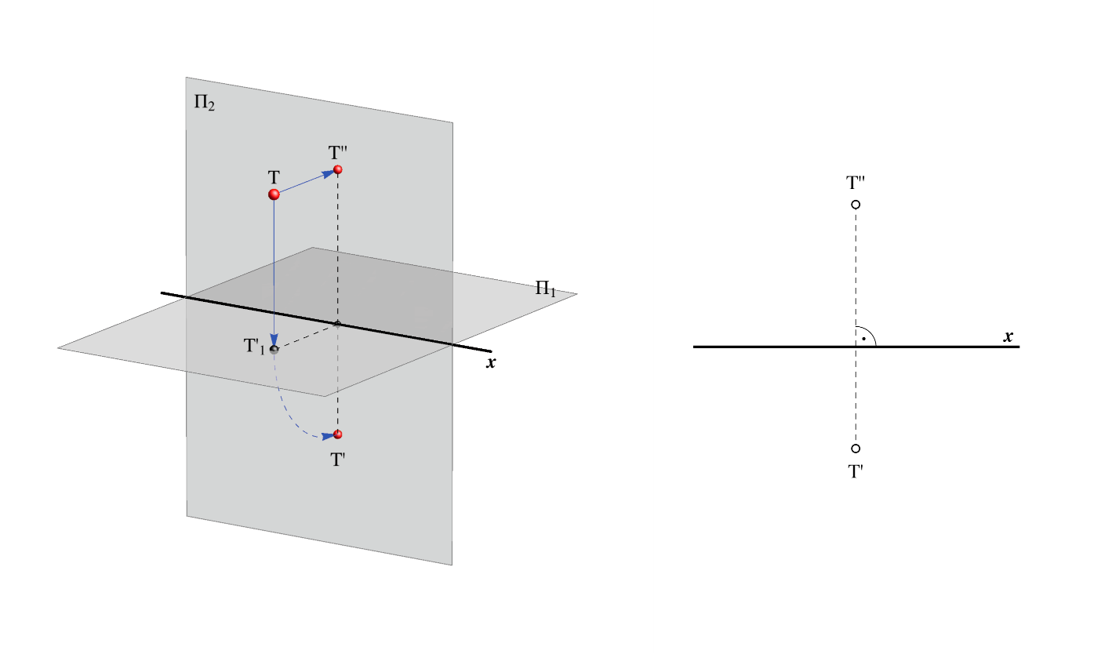

*Experiment 3:* Projection of line

Aim:- Drawing of both simple as well as inclined lines.

* Examples of line parallel to vp
* Examples of line parallel to hp
* Examples of line inclined to vp
* Examples of line inclined to hp
* Conventions and symbols for lines

This experiment is demonstrated by using graphics of pictorial rep to orthogonal rep.

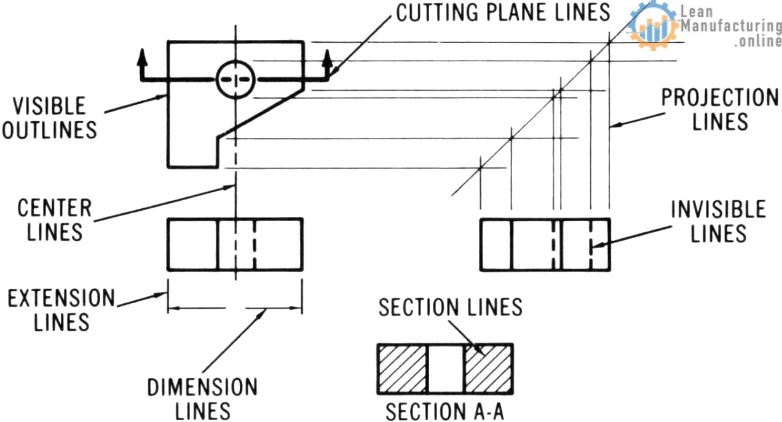

*Experiment 4:* Projection of Line (Part-2)

Aim:-Drawing of line inclined to both plane,mid-point and traces.

* Defining angle theta and phi
* Defining angle alpha and beta
* Exp about true length and new defined terms
* Exp of traces and how to draw mid points
* Finally examples covering all cases Pictorial to orthographic projection .

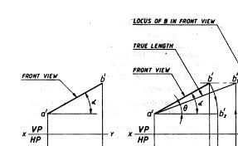

*Experiment 5:* Projection of Planes

Aim:-It includes drawing of surfaces inclined to VP,HP and traces.

* Introduction and standard procedure.
* Drawing of surfaces inclined to both
* Examples of standard shapes ,i.e. rhombus, elliptical & composite plane
* Traces of plane.

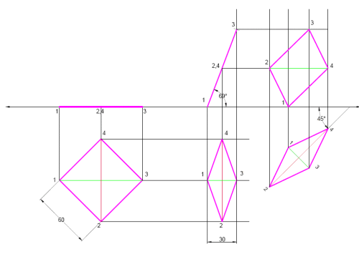

*Experiment 6:* Projection of solid (Part-1)

Aim:-Drawing of inclined to the VP or HP.

* Introduction and standard procedure
* Examples related using pictorial to orthographic view of standard solids.
* Example of solid axis inclined to an angle.

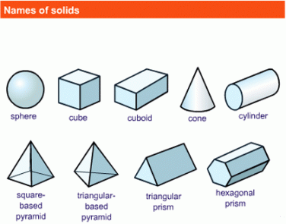

*Experiment 7:* Auxiliary plane Method

Aim:- Drawing of plane using Auxiliary plane method.

* Introduction of Auxiliary plane.
* Drawing of planes using APM

(Here illustration contains both normal method as well as APM for every problem)

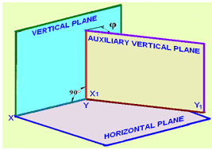

*Experiment 8:* Auxiliary Plane method (Part-2)

Aim:-Drawing of solids using Auxiliary plane method.

* Introduction of different views
* Drawing of solids using Auxiliary plane method.
* Illustrations including both normal and Auxiliary plane method.

*Experiment 9:* Isometric projection

Aim:-Drawing isometric view or projection out of FV and TV

* Difference between isometric view and projection
* Conventions of isographic
* Drawing of isometric scale
* Illustration on isometric view
* Illustration on isometric projection

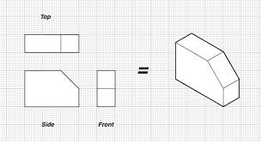

*Experiment 10:* Isometric to Orthographic

Aim:-Drawing of orthographic out of given isometric

* Illustrations on conversions
* Using the 3 isometric views to convert to orthographic projection.

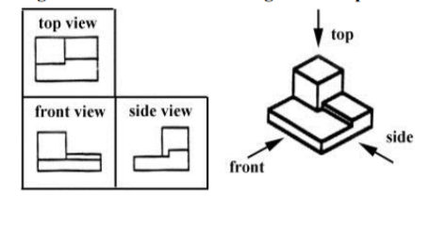

THANK YOU